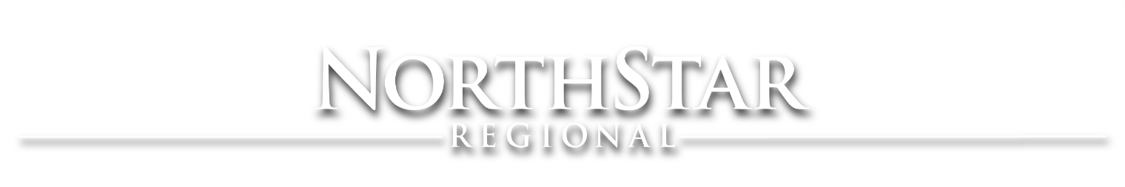
SmartTV Video Loop Set-Up
Please, follow these step-by-step instructions to Loop the NorthStar Regional Facilities Playlist on all available SmartTVs* at NorthStar Regional. This process must be completed whenever a SmartTV gets turned on at any of our locations, in any lobby or common space. So, keep these instructions somewhere handy, to reference them again in the future.

- Locate and open the YouTube Application on the SmartTV.

- Search “northstar regional campus” and select our video.
- Press Up on the remote to select our Channel.

- Select the “Go to Channel” option.

- Select the “FACILITIES LOOP” playlist, and Loop Playlist option.

Should you have any questions or concerns regarding this new process, please refer to your supervisor.
If you encounter any issues with set-up, please contact Marketing.
alexander.vechinski@northstarregional.com
*SmartTVs are LCD and LED displays that can access WiFi and common video platform applications. If you’re unsure about a device or need assistance establishing internet access, please contact IT.
randy.olejnicak@northstarregional.com

